

Join communities across the United States in a national conversation on China

**Wednesday, October 11**

**\*LOCAL VENUE START TIME\***

*LOCAL VENUE ADDRESS*

*REGISTRATION INFO*

Featuring current U.S. Ambassador to China, **Nicholas Burns,**

and an on-site discussion facilitated by *LOCAL FACILITATOR NAME**\***

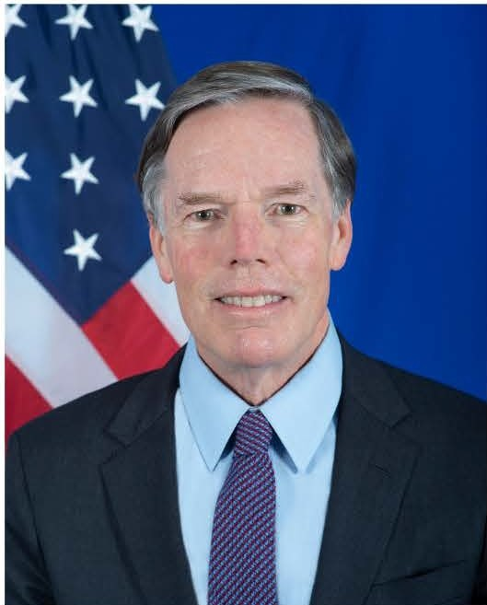

* LOCAL FACILITATOR HEADSHOT•

**Nicholas Burns**

**U.S. Ambassador to China**

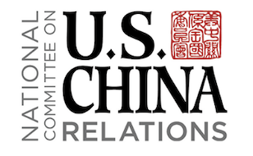*LOCAL FACILITATOR NAME*

*LOCAL VENUE LOGO*